Italian Beef

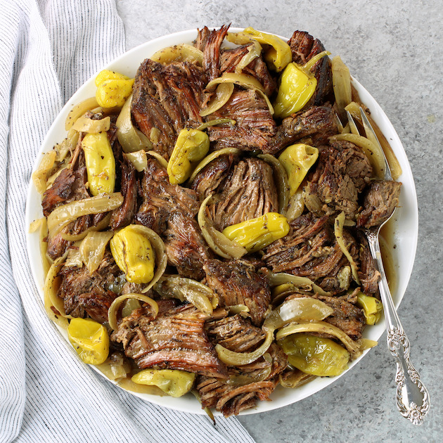

Ingredients

* Beef Roast
* 1 white onion, sliced
* 1 can of beef broth
* Pepperoncini peppers, whole
* McCormick Perfect Pinch Italian seasoning to taste

Directions

1. Place all ingredients into a crockpot.
2. Cook on low until the roast falls apart.